Meme culture is a vibrant corner of the internet, a constantly churning engine of humor and social commentary. At its core, memes are images, videos, or phrases that spread rapidly online, often accompanied by text overlay. These cultural nuggets can be funny, relatable, or even critical, serving as a way for people to share experiences and connect with current events.

One defining feature of memes is their mutability. The original format can be endlessly adapted, taking on new meanings and contexts as it gets shared and reinterpreted. This participatory aspect is key – anyone can create and share a meme, making it a truly democratic form of expression. From reaction images expressing frustration to cleverly captioned photos that perfectly capture a mood, memes offer a quick and witty way to communicate complex ideas.

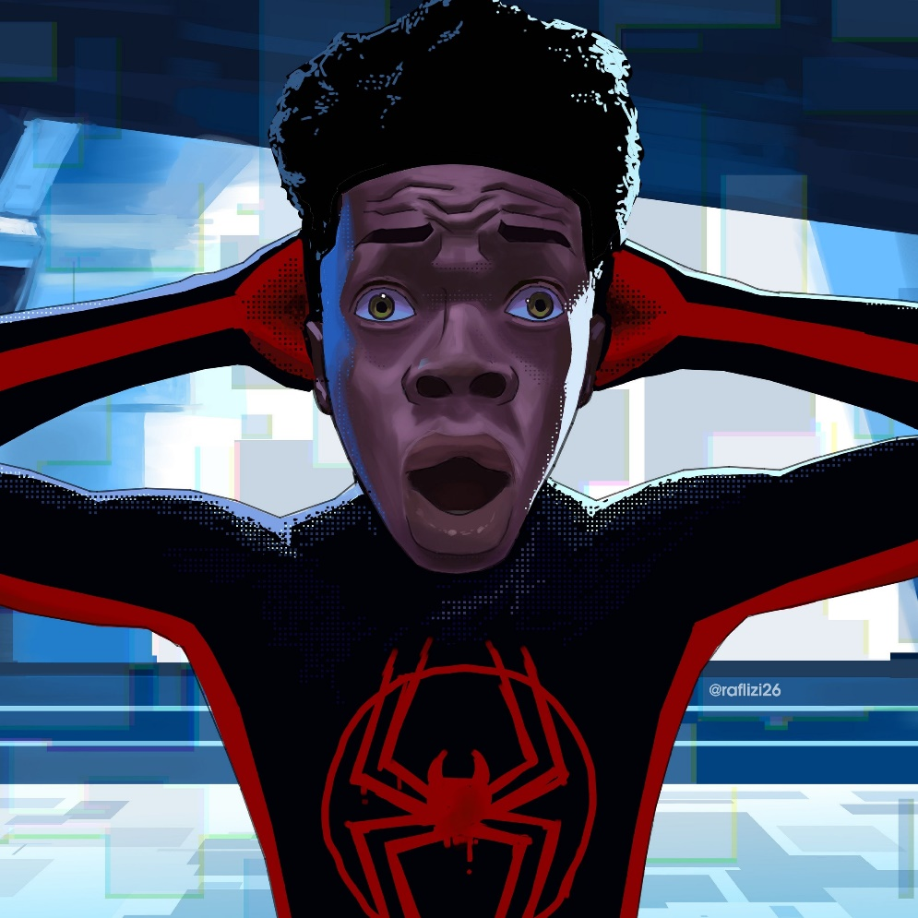

The rapid spread of memes also makes them a powerful tool for social commentary. By using humor and familiar references, memes can spark conversations about everything from politics to pop culture. They can raise awareness about important issues, challenge societal norms, and even influence public opinion. While some memes might be fleeting trends, others can leave a lasting impact on internet culture.